**XR Technology**

Extended Reality is an umbrella term that encapsulates various immersive technologies that can merge the physical world we live in with computer-created virtual worlds. This means that top UX design firms combine various components of computer-altered reality including but not limited to Augmented Reality (AR), Virtual Reality (VR), and Mixed Reality (MR) to develop XR.

 All immersive technologies extend the reality we experience by either blending the virtual and “real” worlds or by creating a fully immersive experience. Recent research revealed that[more than 60% of respondents believed XR will be mainstream in the next five years](https://www.visualcapitalist.com/extended-reality-xr/).

In order to fully understand what Extended Reality is and what it can do, you need to understand the three main components, which are Augmented Reality (AR), Virtual Reality (VR), and Mixed Reality (MR). We explain these below:

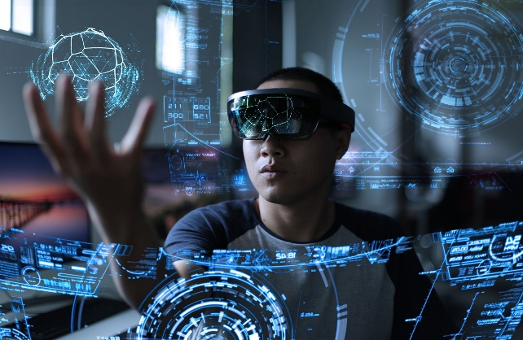 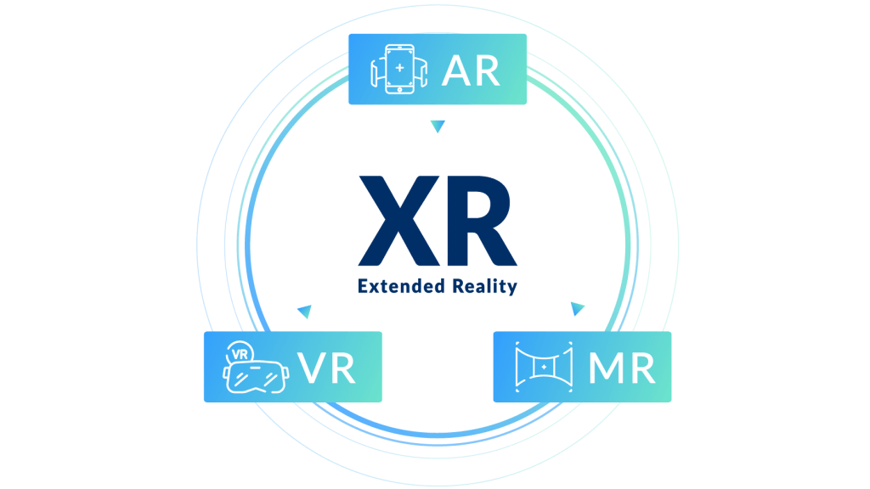

* **Virtual Reality (VR):**

Virtual Reality (VR) is an immersive experience also called a computer-simulated reality. It refers to computer technologies using reality headsets to generate the realistic sounds, images and other sensations that replicate a real environment or create an imaginary world. VR is a way to immerse users in an entirely virtual world. A true VR environment will engage all five senses (taste, sight, smell, touch, sound), but it is important to say that this is not always possible.



Today, it is easy to say that VR is a well-established new reality-tech. Moreover, after years of popularity in the gaming industry, we are now seeing this technology into more practical applications. The market and the industry are still excited about this tech trend and further progress is expected soon.

* **Augmented Reality (AR):**

Augmented Reality (AR) is a live, direct or indirect view of a physical, real-world environment whose elements are augmented (or supplemented) by computer-generated sensory input such as sound, video, graphics or GPS data. As AR exists on top of our own world it provides as much freedom as you are given within your normal life. AR utilizes your existing reality and adds to it utilizing a device of some sort. Mobile and tablets are the most popular mediums of AR now, through the camera, the apps put an overlay of digital content into the environment. Custom headsets are also being used. As popular AR examples there are Pokémon Go and Snapchat’s new AR bitmojis.

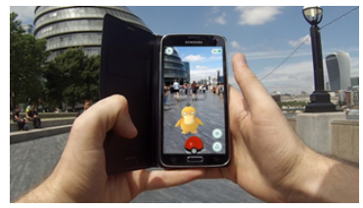

* **Mixed Reality (MR):**

Mixed Reality (MR), sometimes referred to as hybrid reality, is the merging of real and virtual worlds to produce new environments and visualizations where physical and digital objects co-exist and interact in real time. It means placing new imagery within a real space in such a way that the new imagery can interact, to an extent, with what is real in the physical world we know. The key characteristic of MR is that the synthetic content and the real-world content can react to each other in real time.

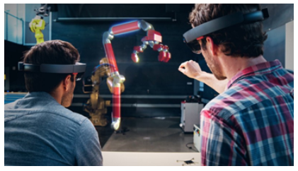

* **Extended Reality (XR):**

Extended Reality (XR) is a newly added term to the dictionary of the technical words. For now, only a few people are aware of XR. Extended Reality refers to all real-and-virtual combined environments and human-machine interactions generated by computer technology and wearables. Extended Reality includes all its descriptive forms like the Augmented Reality (AR), Virtual Reality (VR), Mixed Reality (MR). In other words, XR can be defined as an umbrella, which brings all three Reality (AR, VR, MR) together under one term, leading to less public confusion. Extended reality provides a wide variety and vast number of levels in the Virtuality of partially sensor inputs to Immersive Virtuality.

Since past few years, we have been talking regarding AR, VR, and MR, and probably in coming years, we will be speaking about XR.

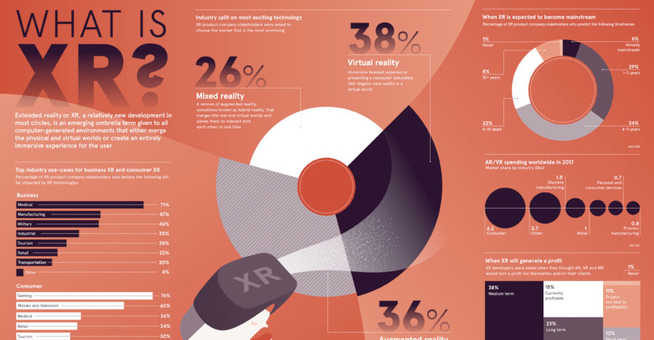

**Future scope of Extended Reality:**

Recent research has revealed that more than a whopping 60 percent of the respondents believe that Extended Reality will become mainstream in the just the next five years. This shows just how rapidly this technology is being developed, and how willingly the public is ready to adopt it once it is ready and available in the market.

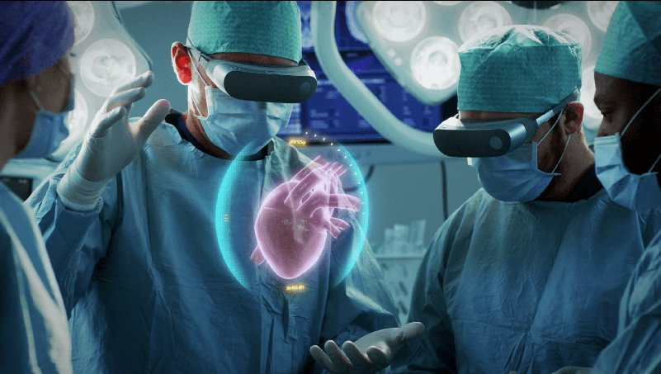

Indeed, Extended Reality has plenty of uses and could be employed in all kinds of fields such as retail, real estate, marketing, training, entertainment, and more. It can also be used by the best UI UX design services. The technology has the potential to completely change the way we live our everyday lives, as it will alter our very perception of reality.

**Extended Reality Applications for Business:**

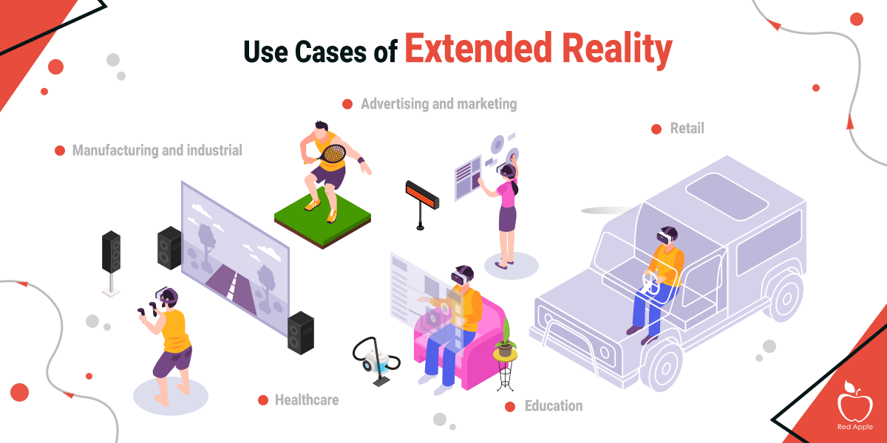

There are many practical applications of XR. Here are a few:

* **Retail**: XR gives customers the ability to try before they buy. Watch manufacturer Rolex has an AR app that allows you to try on watches on your actual wrist, and furniture company IKEA gives customers the ability to place furniture items into their home via their smartphone.
* **Training**: Especially in life-and-death circumstances, XR can provide training tools that are hyper-realistic that will help soldiers, healthcare professionals, pilots/astronauts, chemists, and more figure out solutions to problems or learn how to respond to dangerous circumstances without putting their lives or anyone else's at risk.
* **Remote work**: Workers can connect to the home office or with professionals located around the world in a way that makes both sides feel like they are in the same room.
* **Marketing**: The possibilities to engage with prospective customers and consumers through XR will have marketing professionals pondering all the potential of using XR to their company’s advantage.
* **Real estate**: Finding buyers or tenants might be easier if individuals can “walk through” spaces to decide if they want it even when they are in some other location.
* **Entertainment**: As an early adopter, the entertainment industry will continue to find new ways of utilizing immersive technologies.

**Challenges of XR:**

Those developing XR technologies are battling with some of the challenges to mainstream adoption. First, XR technologies collect and process huge amounts of very detailed and personal data about what you do, what you look at, and even your emotions at any given time, which must be protected.

In addition, the cost of implementing the technology needs to come down; otherwise, many companies will be unable to invest in it. It is essential that the wearable devices that allow a full XR experience are fashionable and comfortable as well as always connected, intelligent, and immersive. There are significant technical and hardware issues to solve that include but are not limited to the display, power and thermal, motion tracking, connectivity and common illumination—where virtual objects in a real world are indistinguishable from real objects especially as lighting shifts.

As each day passes, we are one step closer to solving these issues so that we will see many more mainstream applications of all XR technologies over the coming years.